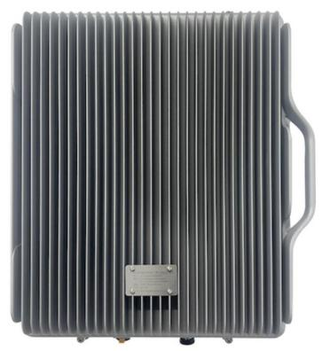
Dual band 700&TDD2600MHz BDA - 10W

Model: AS-700&TDD2600-40

Working Schematic Diagram
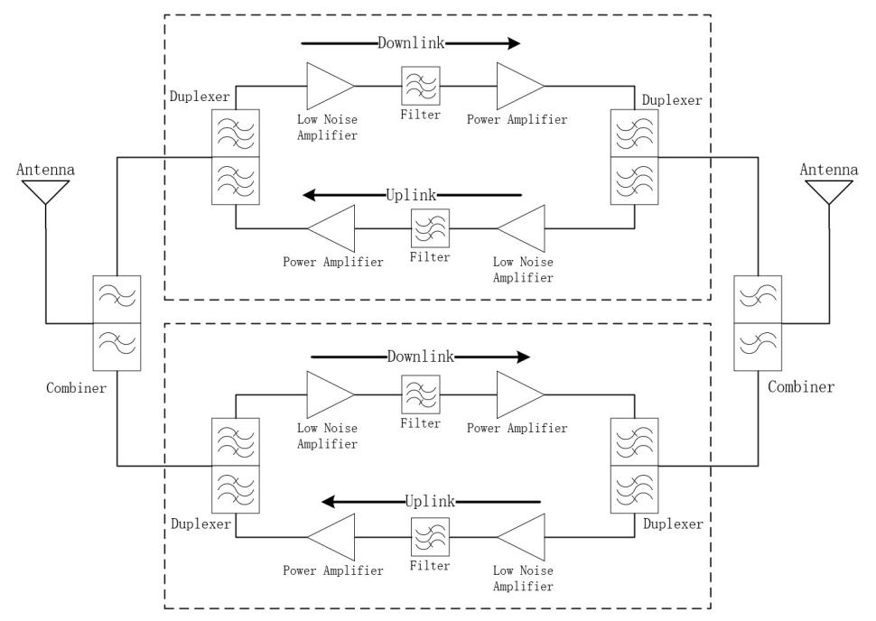

Technical Specifications:
Part Number | AS-700&TDD2600-40
Frequency Band | 700MHz:UL:703-748MHz，DL:758-803MHz  TDD2600MHz：UL/DL:2496-2690MHz
Bandwidth | 35MHz&194MHz
Uplink Gain | 85+3dB
Downlink Gain | 90+3dB
Uplink Output Power | 30+2dBm
Downlink Output Power | 40+2dBm
Gain Adjustment Range | 0 - 31dB @1dB step
ALC Range | > 20dB
System Delay | < 1µs
VSWR | < 2.5
Noise Figure (Uplink) | < 8dB
RF Connector | 2* N (f)
Power Consumption | < 500W
Power Supply | AC110-240V
Local Monitor&Control | LCD + Keypad
Approx. Weight | 25kg
Working Temperature | -10 to + 55°C
Application | Indoor&Outdoor (IP65)
Humidity | 5% to 95%
Installation Method | Wall or Pole mount
Dimension | 513mm*440mm*233mm

Technical specification is subject to change without prior notice.

